Outlook Express E-Mail Setup (for versions 5.x and 6.0)
- Open Outlook Express and click on the Tools menu and then select Accounts.
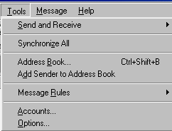
- Click the Add button and select Mail from the submenu.
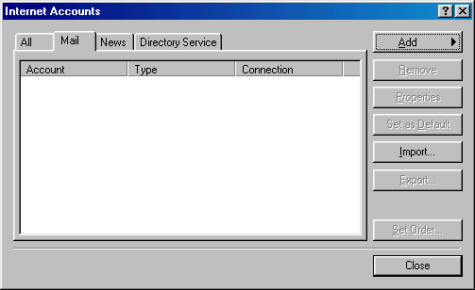
- In the Display name blank, type your name. Click NEXT.
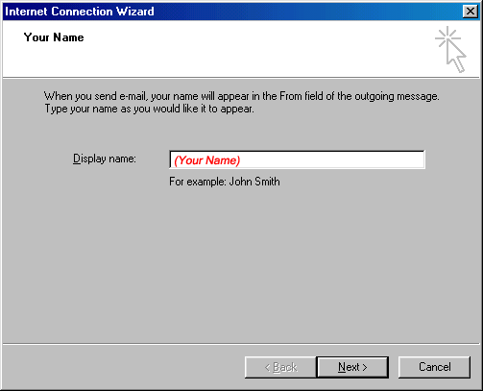
- In the E-Mail address blank, type your full e-mail address. Click NEXT.
Note: In Outlook Express 5.5 you will need to select "I already have an e-mail address I would like to use" and then type your e-mail address in the blank next to it.
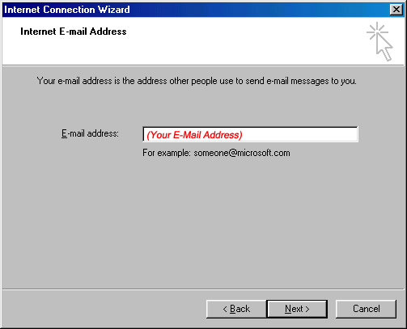
- Select POP3 as the incoming mail server. In the Incoming mail server blank, type (yourdomain.com) In the Outgoing mail server blank, type (yourdomain.com OR yourISPmailserver) Click NEXT.
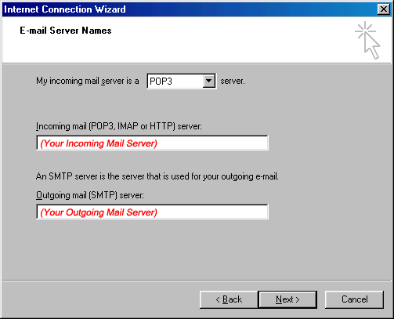
- Enter your username and password here. Check the Remember Password box if you want your password saved.
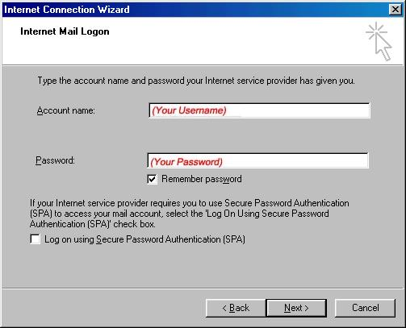
- Click FINISH. You can now send and receive your e-mail.
