Outlook 2002 E-Mail Setup
- Open Outlook 2002. Click on the Tools menu and select E-Mail Accounts.
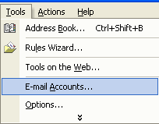
- Select Add a new e-mail account. Click NEXT.
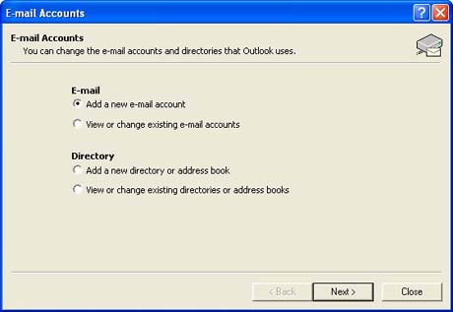
- Select POP3 and then click NEXT.
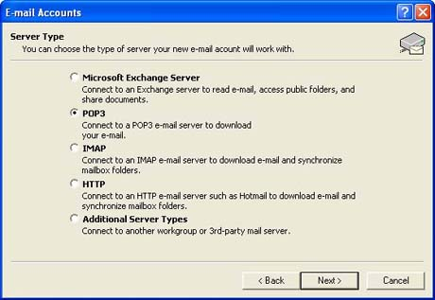
- Enter your name, e-mail address, incoming and outgoing mail servers, and your username and password. Click NEXT.
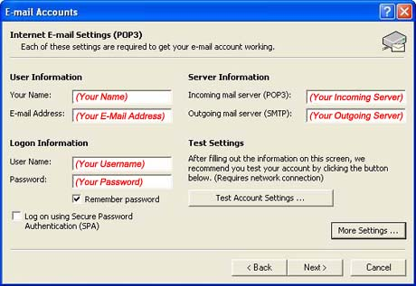
- Click FINISH. You can now use your new e-mail. To check for new messages, click the Send/Receive icon.
