Outlook 2000 E-Mail Setup
- Open Outlook 2000. Click on the Tools menu and select Accounts.
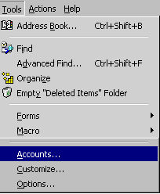
- Click the Add button and select Mail from the sub-menu.
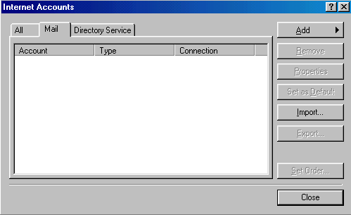

- In the Display name blank, type your name as you would like it to appear on your outgoing mail messages. Click NEXT.
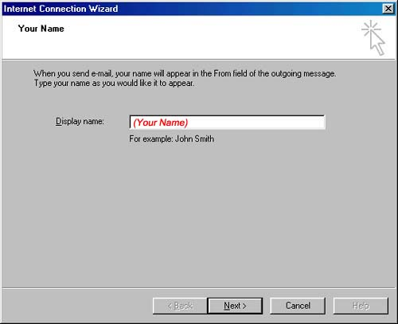
- In the E-Mail address blank, type your full e-mail address. Click NEXT.
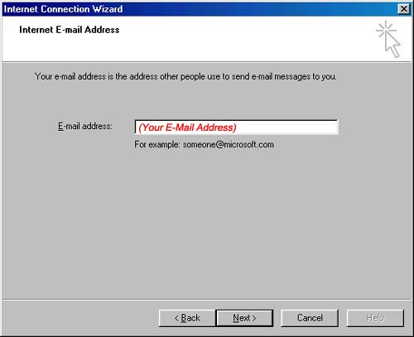
- Select POP3 as the incoming mail server type at the top. In the Incoming mail server blank, type (your incoming mail server) In the Outgoing mail server blank, type (your outgoing mail server) Click NEXT.
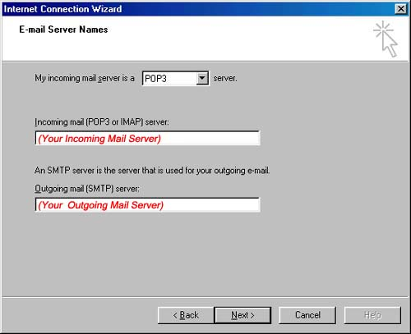
- Type in your username and password here and click NEXT.
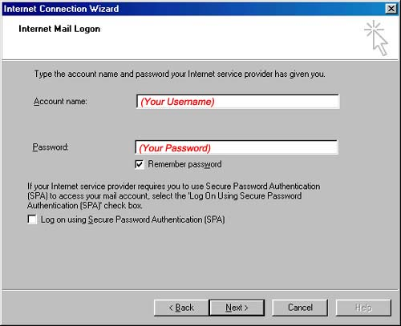
- Select I will establish my Internet connection manually if you are using dial-up. Select Connect using my local area network (LAN) if you are using DSL. Click NEXT.
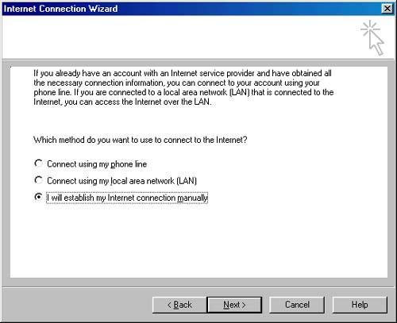
- Click FINISH. You can now use your e-mail.
